Aim: Portfolio Website using Flask

1. Micro-Framework Architecture
Flask is a micro-framework for Python based on Werkzeug and Jinja2. Unlike heavy frameworks, it is lightweight and allows for modular development, which is ideal for creating personal portfolios with custom logic.

2. Client-Server Routing
In Flask, routing is handled via decorators (e.g., @app.route('/')). This allows the server to map specific URL paths to Python functions that render the appropriate HTML templates.

3. Jinja2 and Dynamic Content
Flask utilizes the Jinja2 engine to enable Template Inheritance. This allows a developer to create a "base" layout (containing the navbar and footer) that other pages inherit, ensuring a consistent UI across the Home, About, and Project sections.

Cover Page (Home)
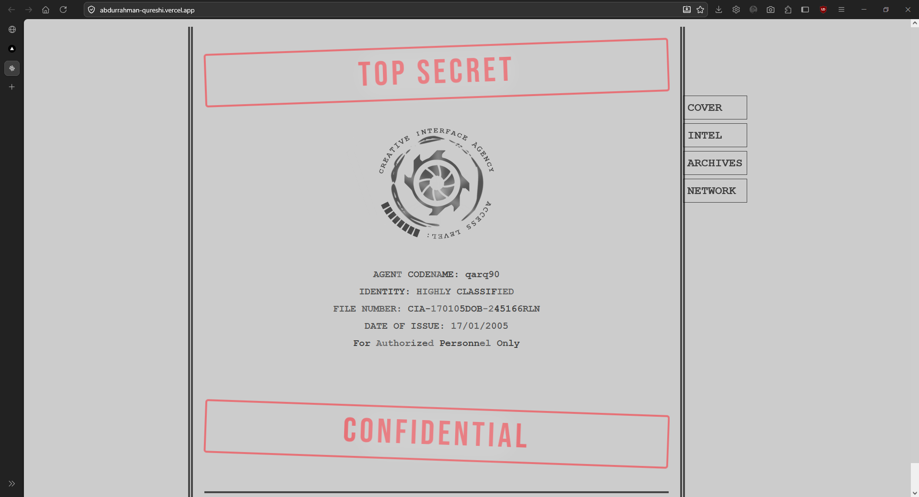

Intel Page (About)
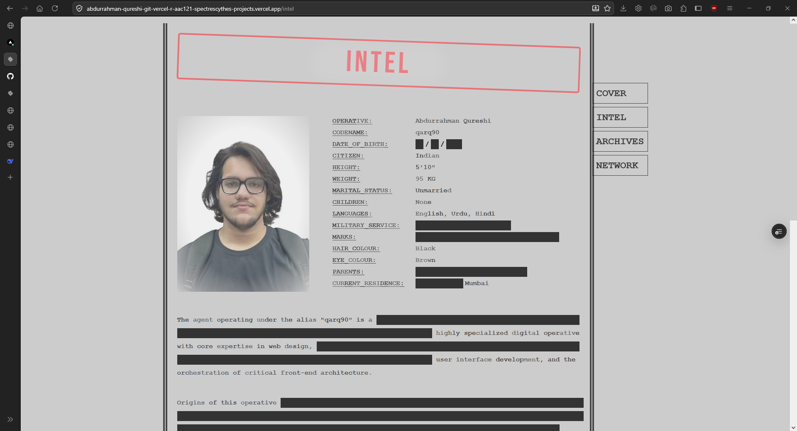

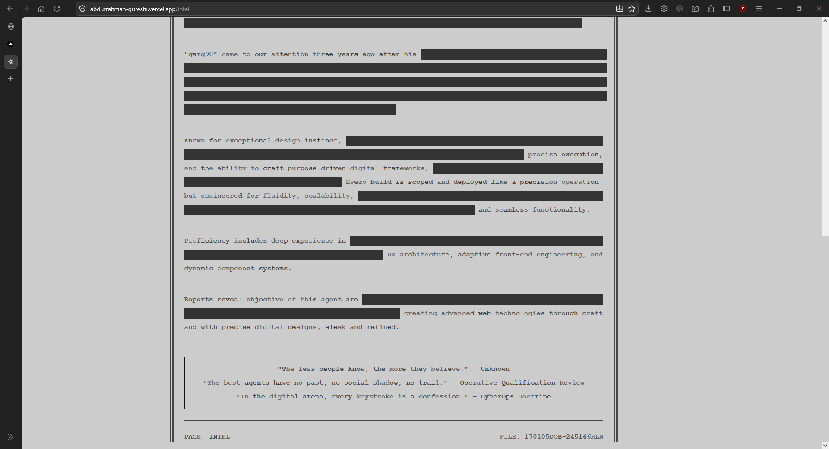

Archives Page (Works)
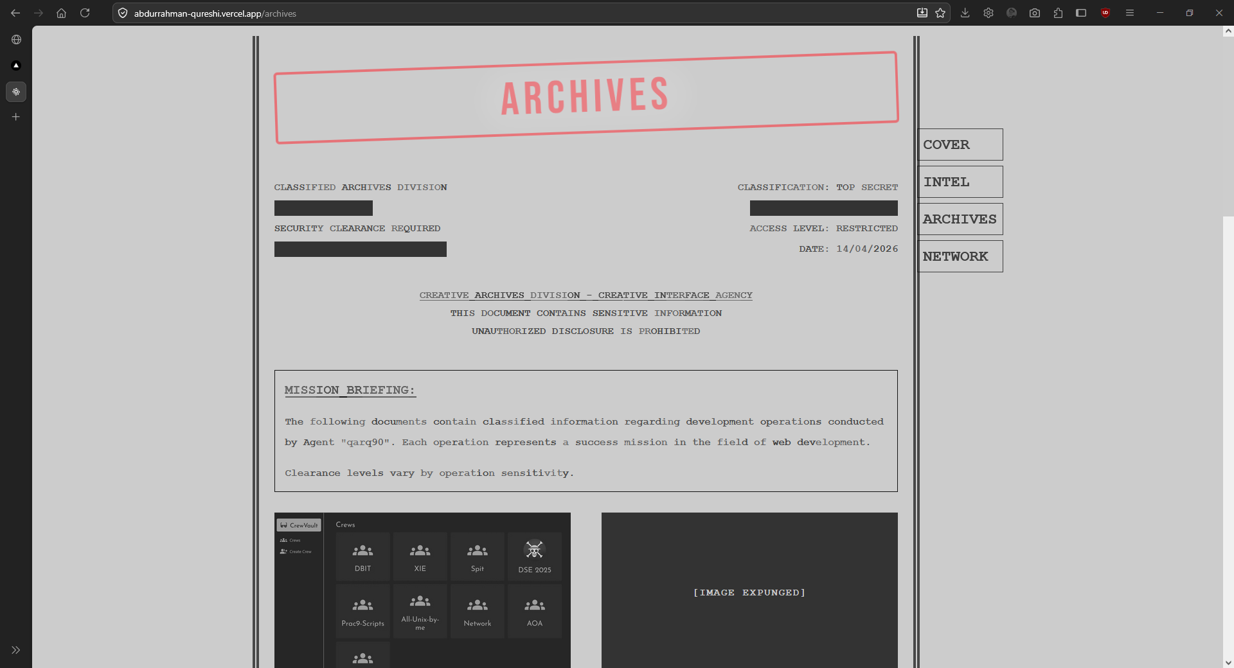

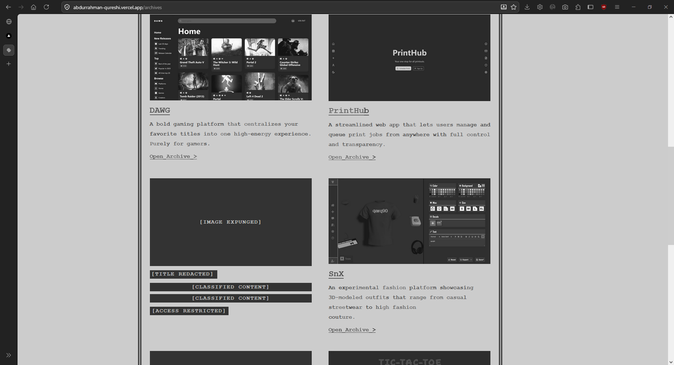

Network Page (Contact)
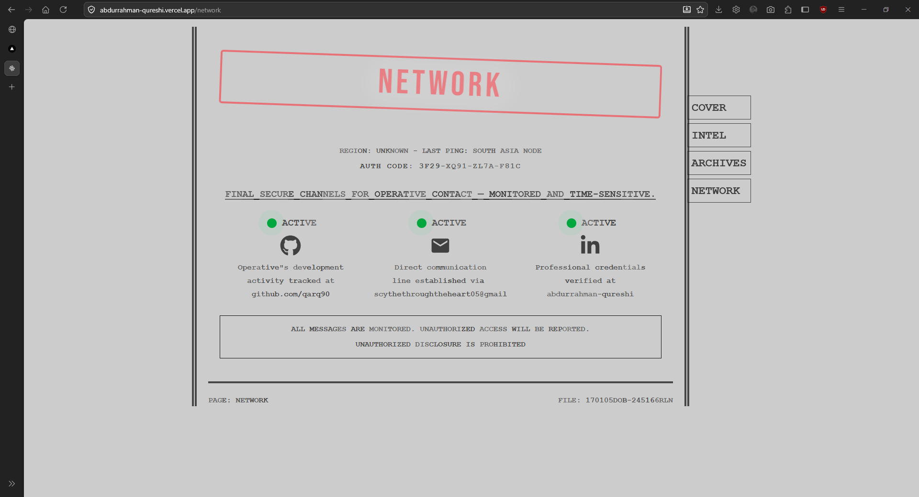

Conclusion
The Flask Portfolio successfully integrates multiple web development concepts into a single cohesive application. By leveraging routing and Jinja2 templates, the site maintains a professional and consistent terminal aesthetic.

